**Name - Gaurang A Raorane Roll No - 49**

**Class - D15A Batch - C**

**EXPERIMENT NO - 1**

**Aim :-** Experiment to study basics of HTML5 and basic tags of HTML5.

**Theory :-**

**HTML -** HTML5 (Hypertext Markup Language 5) is the latest version of the standard markup language used to create and structure content on the World Wide Web. It introduces new features, better semantics, and improved support for multimedia elements.

An HTML5 document follows a specific structure. Here's a basic template:

* <!DOCTYPE html> declares the document type and version.
* <html> is the root element.
* <head> contains meta-information about the document.
* <title> sets the title of the web page, displayed in the browser's title bar.
* <body> contains the visible content of the web page.

Text Formatting Tags

* <h1> to <h6>: Header tags for creating headings.
* <p>: Paragraph tag for text paragraphs.
* <strong> and <em>: Tags for strong and emphasized text respectively.
* <u>: Underline text.
* <br>: Line break tag.
* <hr>: Horizontal rule tag.
* <a>: Anchor tag used for creating hyperlinks.
* href: Attribute specifying the URL to link to.

Image Tags

* <img>: Image tag to display images.
* src: Attribute with the image URL.
* alt: Attribute providing alternative text for screen readers.

Ordered List:  
<ul>: Unordered list tag.

* <ol>: Ordered list tag.
* <li>: List item tag.

#### Table Tags :-

* <table>: Table tag for creating tables.
* <tr>: Table row tag.
* <th>: Table header cell tag.
* <td>: Table data cell tag.

**Programs:**

**(a) To create a personal profile using basic HTML tags.**

index.html

<!DOCTYPE html>

<html lang="en">

<head>

<meta charset="UTF-8">

<meta name="viewport" content="width=device-width, initial-scale=1.0">

<title>Gaurang Raorane</title>

</head>

<body>

<h1>Gaurang Raorane's Portfolio</h1>

<h2>I am a Web Developer</h2>

<hr>

<h3>Here is a List of few projects which I have made:</h3>

<ol>

<li><a href="https://github.com/gitgaurang/Easy-Tax1"><h3>Easy Tax</h3></a></li>

<p>This project helps user to predict his or her taxable income.</p>

<p>Tech Stack used:</p>

<ul>

<li>Java AWT</li>

<li>MySQL</li>

</ul>

<li><a href="https://github.com/pranavraikar01/ScrapeSonic"><h3>ScrapeSonic</h3></a></li>

<p>This is based on webscraping where it scrapes the prices of books from different sellers and helps the user take the informed decision. </p>

<ul>

<li>Python Tkinter</li>

<li>BeautifulSoup</li>

<li>MySQL</li>

</ul>

</ol>

<p>

<h3>Skills</h3>

<ol>

<li><h3>Technical Skills</h3></li>

<ul>

<li>Java</li>

<li>Python</li>

<li>SQL</li>

<li>HTML</li>

</ul>

<li><h3>Soft-Skills</h3></li>

<ul>

<li>Efficient Communicator</li>

<p>I can not just only efficiently communicate but can draw that communication to a meaningful conclusion.</p>

<li>Leadership Qualities</li>

<p>I have always taken a position of responsibility whenever and wherever needed.</p>

</ul>

</ol>

<hr>

<a href="./contact.html"><h3>Contact</h3></a>

</p>

</body>

</html>

Contact.html

<h1>Gaurang Raorane</h1>

<p>Name: Gaurang A Raoarane<br />

Phone No: +91-8108470291<br />

E-Mail: gaurangraorane@gmail.com<br />

Navi Mumbai<br />

India<br />

</p>

**Output :-**

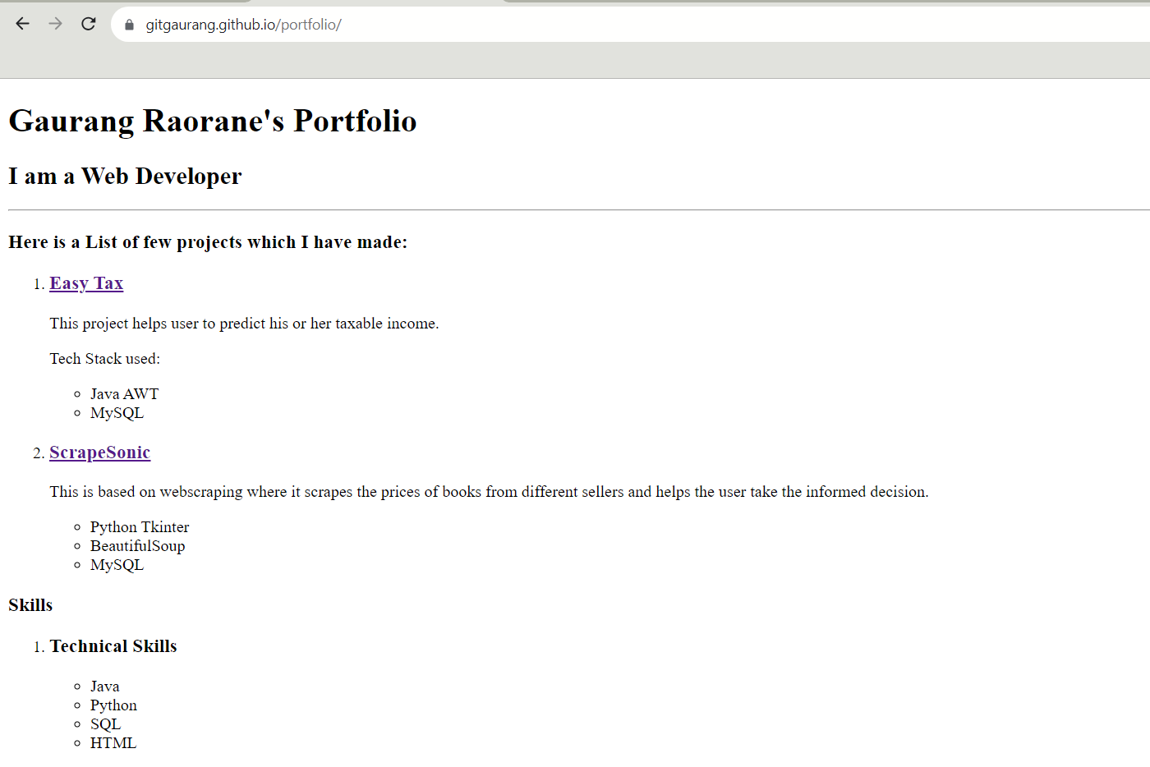

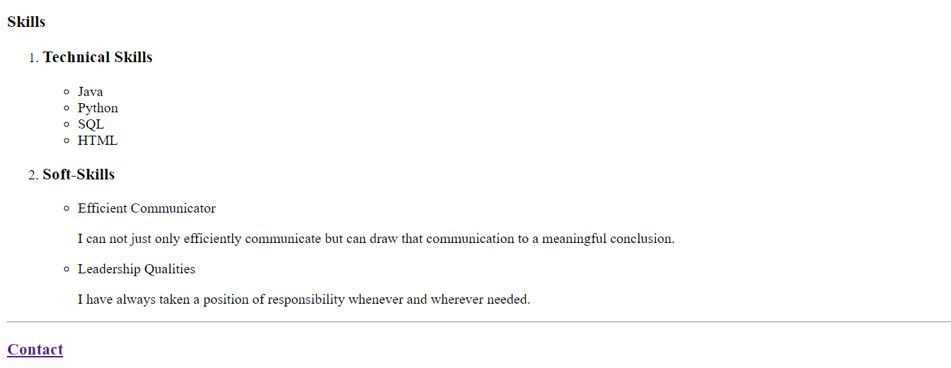

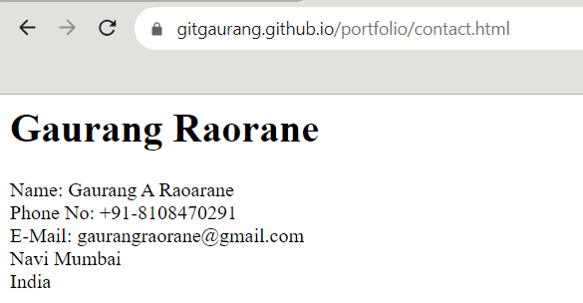

**(b) Create a Marksheet using advanced table tags.**

**Input :-**

<!DOCTYPE html>

<html>

<head>

<title>Marksheet</title>

<style>

table {

width: 50%;

margin: 0 auto;

border-collapse: collapse;

border: 1px solid #ccc;

}

th, td {

border: 1px solid #ccc;

padding: 8px;

text-align: center;

}

th {

background-color: #f2f2f2;

}

</style>

</head>

<body>

<h1>Marksheet</h1>

<table>

<caption>Student Marksheet</caption>

<colgroup>

<col style="width: 50%">

<col style="width: 25%">

<col style="width: 25%">

</colgroup>

<thead>

<tr>

<th>Subject</th>

<th>Marks Obtained</th>

<th>Total Marks</th>

</tr>

</thead>

<tbody>

<tr>

<td>Mathematics</td>

<td>90</td>

<td>100</td>

</tr>

<tr>

<td>Science</td>

<td>85</td>

<td>100</td>

</tr>

<tr>

<td>English</td>

<td>75</td>

<td>100</td>

</tr>

</tbody>

<tfoot>

<tr>

<td colspan="3">Overall Percentage: 83%</td>

</tr>

</tfoot>

</table>

</body>

</html>

**Output:-**

